The World Heritage Convention

Background

The idea of creating an international movement for protecting heritage emerged after World War I. The 1972 Convention concerning the Protection of the World Cultural and Natural Heritage developed from the merging of two separate movements: the first focusing on the preservation of cultural sites, and the other dealing with the conservation of nature. The World Heritage Convention was adopted by the United Nations Educational, Scientific and Cultural Organisation (UNESCO) General Conference on 16 November 1972. The Convention came into force in 1975. In August 1974, Australia became one of the first countries to ratify (approve) the Convention.

Aims
The World Heritage Convention aims to promote cooperation among nations to protect heritage around the world that is of such outstanding universal value that its conservation is important for current and future generations.
It is intended that, unlike the seven wonders of the ancient world, properties on the World Heritage List will be conserved for all time.

The role and responsibility of participating nations
States that are parties to the Convention agree to identify, protect, conserve, and present World Heritage properties. States recognise that the identification and safeguarding of heritage located in their territory is primarily their responsibility. They agree to do all they can with their own resources to protect their World Heritage properties.
They agree, amongst other things, as far as possible to:
- 'adopt a general policy that aims to give the cultural and natural heritage a function in the life of the community and to integrate the protection of that heritage into comprehensive planning programs'
- undertake 'appropriate legal, scientific, technical, administrative and financial measures necessary for the identification, protection, conservation, presentation and rehabilitation of this heritage'
- refrain from 'any deliberate measures which might damage, directly or indirectly, the cultural and natural heritage' of other Parties to the Convention, and to help other Parties in the identification and protection of their properties.

Administering the World Heritage Convention
The World Heritage Convention is administered by a World Heritage Committee, which meets annually and consists of 21 members elected from those States that are parties to the Convention. Elections are held every two years and members are generally elected for four years. Australia has been a member of the Committee on a number of occasions. In October 2007, Australia was elected as a member of the Committee for a four year term.

The Committee's main tasks are to:
- decide on the inscription of new properties on the World Heritage List
- discuss all matters relating to the implementation of the Convention
- consider requests for international assistance
- advise State Parties on how they can ensure States meet their obligations under the Convention to protect World Heritage Properties
- administer the World Heritage Fund.
The Committee is supported by a small secretariat, the World Heritage Centre, which is a part of the United Nations Educational, Scientific and Cultural Organisation (UNESCO) based in Paris, France.

The World Heritage List
The Convention establishes a list of properties that have outstanding universal value, called the World Heritage List. These properties are part of the cultural and natural heritage of States that are Parties to the Convention.
The World Heritage List comprises 1121 properties of Outstanding Universal Value. Natural sites represent about 23% of this list, including 39 mixed (both cultural and natural) sites and 213 natural sites.
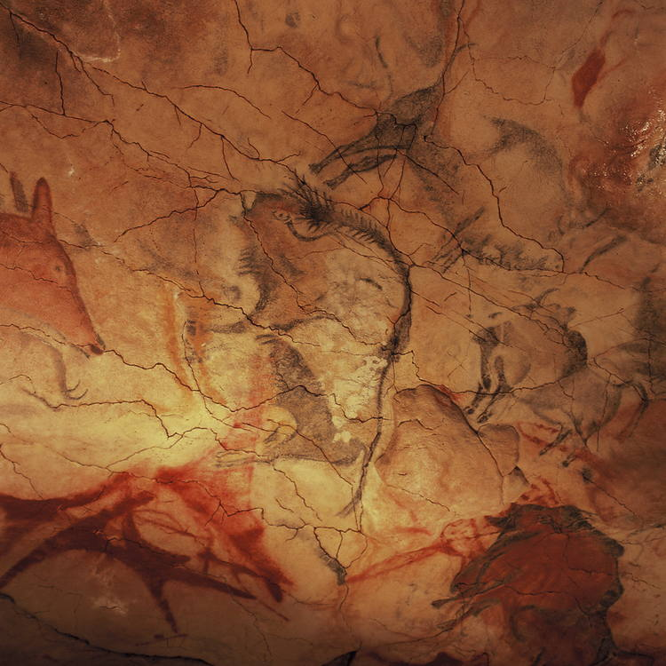
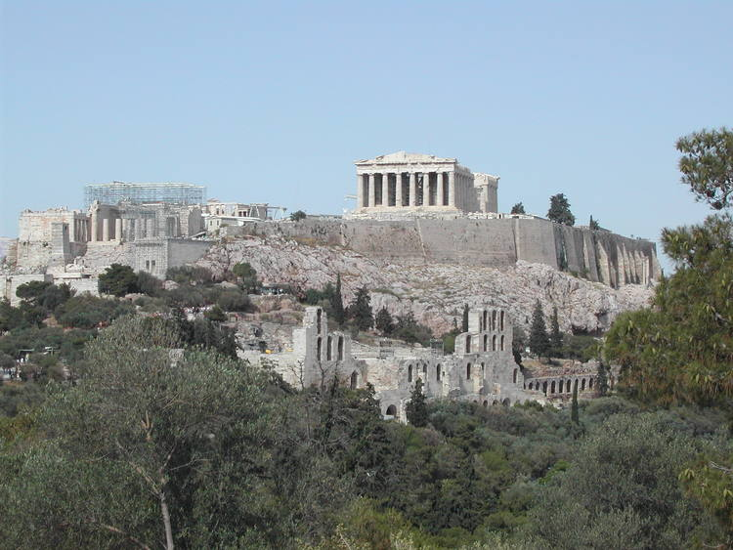
Examples of international cultural sites on the World Heritage List include:
The Acropolis, Athens, Greece

Cave of Altamira and Paleolithic Cave Art of Northern Spain
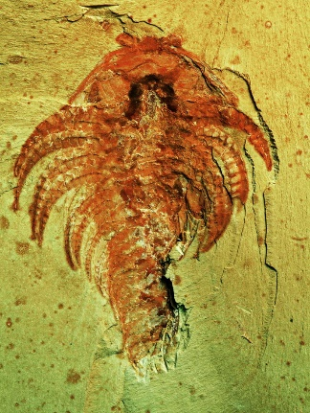
and natural sites
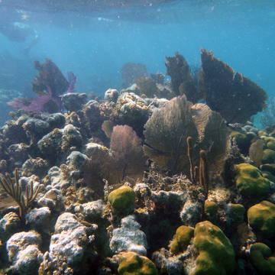
Chengjiang Fossil Site, Yunnan province, China

Barrier Reef Reserve System, Belize

Bibliography
Department of Agriculture, Water and the Environment. (n.d.). The World Heritage Convention. Retrieved 10 30, 2020, from Australian Government: https://www.environment.gov.au/heritage/about/world/world-heritage-convention
United Nations. (2020). The World Heritage Convention. Retrieved October 31, 2020, from United Nations Educational Scientific and Cultural Organisation: https://whc.unesco.org/en/convention/

The World Heritage Convention
Read the extract for the Department of Agriculture, Water and the Environment and answer the questions below:
1. Why does World Heritage Convention exist?

2. Use the table below to list the three key dates, in chronological order, relating to the creation of The World Heritage Convention.
Date | Event
3. Outline the aims of the World Heritage Convention

4. Identify the roles of the members of the World Heritage Convention

5. How many World Heritage sites are there, and what percentage of these are natural sites?

6. Considering the examples of cultural and natural sites included in the article, identify and list possible examples of cultural, natural and a mix of natural and cultural sites in Australia.
Natural sites: | Cultural sites: | Mixed sites:

The World Heritage Convention - Suggested Answers
Read the extract for the Department of Agriculture, Water and the Environment and answer the questions below:
1. Why does World Heritage Convention exist?
The idea behind the World Heritage Convention began after World War I to protect the world’s cultural and natural heritage
2. Use the table below to list the three key dates, in chronological order, relating to the creation of The World Heritage Convention.
Date | Event
16 November 1972 | The World Heritage Convention was adopted by the United Nations Educational, Scientific and Cultural Organisation (UNESCO)
August 1974 | Australia ratified the Convention.
1975 | The World Heritage Convention came into force

3. Outline the aims of the World Heritage Convention
The aim of the World Heritage Convention is to encourage the cooperation between nations to protect heritage sites around the world for all time.
4. Identify the roles of the members of the World Heritage Convention
The key roles of the World Heritage Convention members are to:
- identify, protect, conserve, and present World Heritage sites
- use their own resources to protect their World Heritage sites
- avoid damaging other members heritage sites
5. How many World Heritage sites are there, and what percentage of these are natural sites?
There are 1121 properties of Outstanding Universal Value of which 23% are natural sites.
6. Considering the examples of cultural and natural sites included in the article, identify and list possible examples of cultural, natural and a mix of natural and cultural sites in Australia.
Natural sites: | Cultural sites: | Mixed sites:
- Great Barrier Reef  - Lord Howe Island Group  - Gondwana Rainforests of Australia  - Wet Tropics of Queensland  - Shark Bay, Western Australia  - Fraser Island  - Australian Fossil Mammal Sites (Riversleigh / Naracoorte)  - Heard and McDonald Islands  - Macquarie Island  - Greater Blue Mountains Area  - Purnululu National Park  - Ningaloo Coast | - Uluru-Kata Tjuta National Park  - Royal Exhibition Building and Carlton Gardens  - Sydney Opera House  - Australian Convict Sites  - Budj Bim Cultural Landscape | - Kakadu National Park  - Willandra Lakes Region  - Tasmanian Wilderness

